FACULTY OF ENGINEERING AND ARCHITECTURE DEPARTMENT OF MECHATRONICS ENGINEERING

SLIDER-CRANK MECHANISM

230412036 Işık Çalım
230412057 Büşra Kocaman
230412062 Zeynep Bengisu Lisan
210412074 İclal Yiğitoğlu
210412040 İsmet Akalın
210412047 Haktan Gürsoy
210412060 Levent Sancak

22.12.2025
1. Drawings / Design
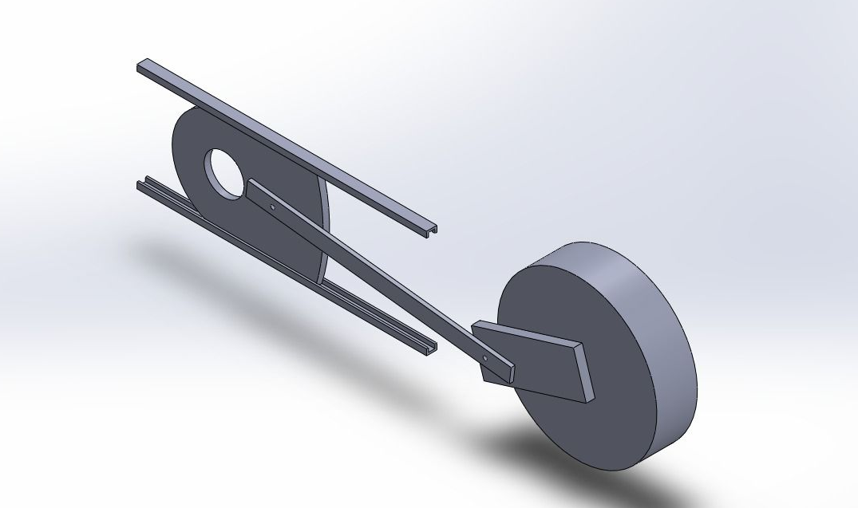
Fig.1

The slider–crank mechanism consists of a crank, a connecting rod, a slider, and a fixed frame.
The crank converts the rotational motion of the shaft into linear motion through the connecting rod.
The mechanism was modeled using SolidWorks to visualize the assembly and verify the compatibility of the components.
A kinematic animation was also created to observe the motion of the slider during one full crank revolution.
During the design stage, the links were assumed to be rigid and the joints were considered ideal in order to simplify the kinematic analysis.
A 3D CAD model of the designed slider–crank mechanism is shown in Figure 1.
2. Calculations

2.1 Matlab Calculations
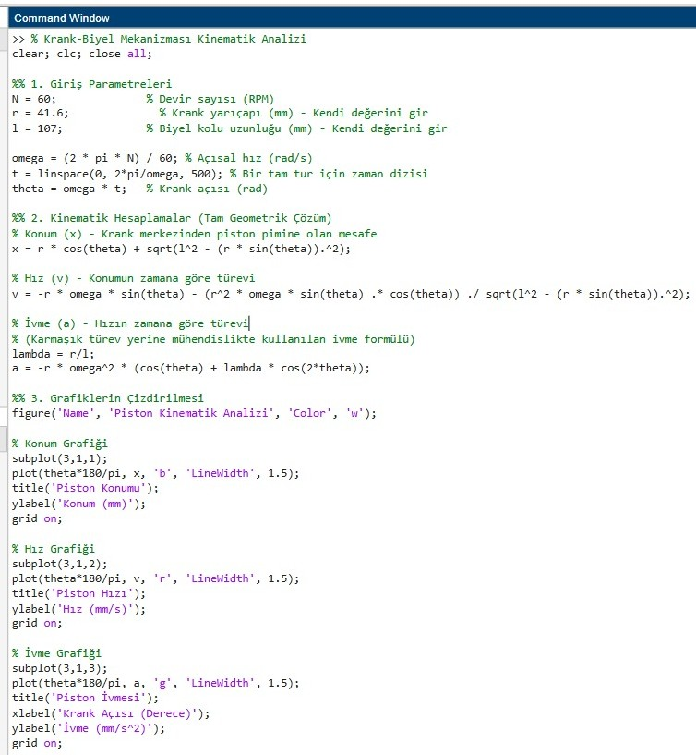
Fig.2

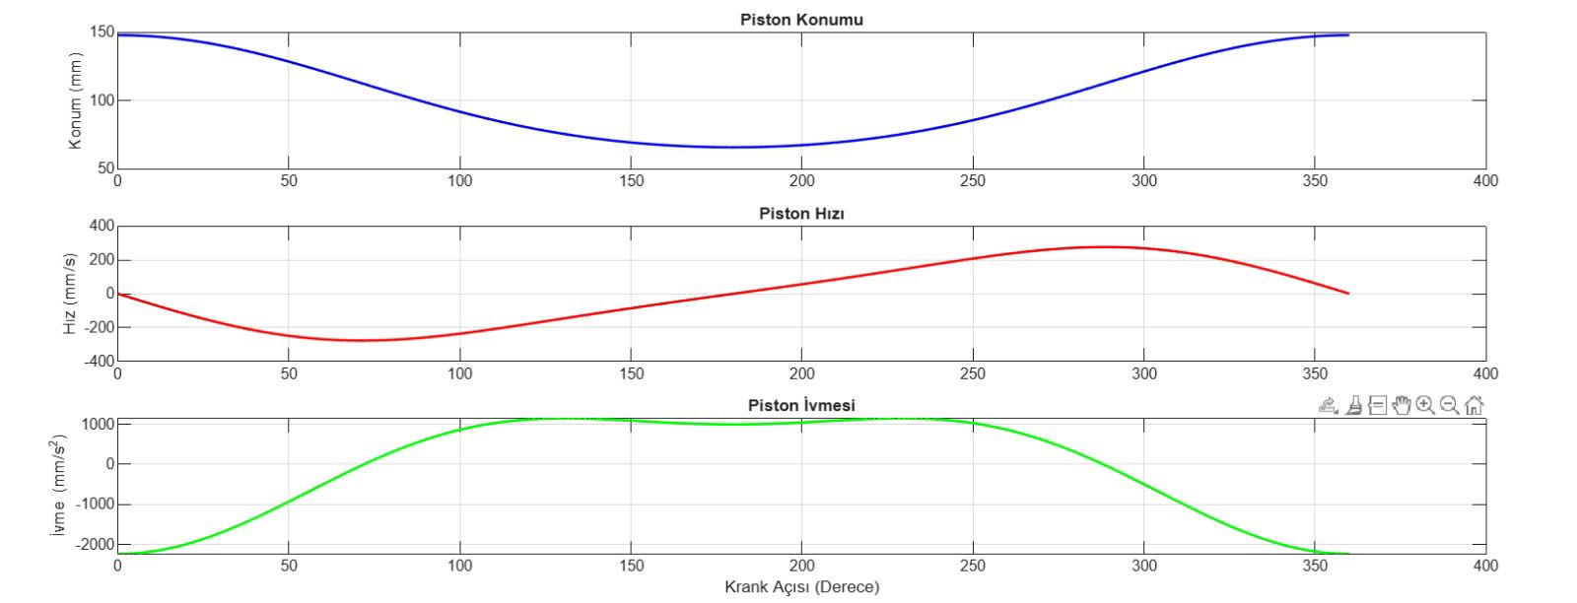
Fig.3
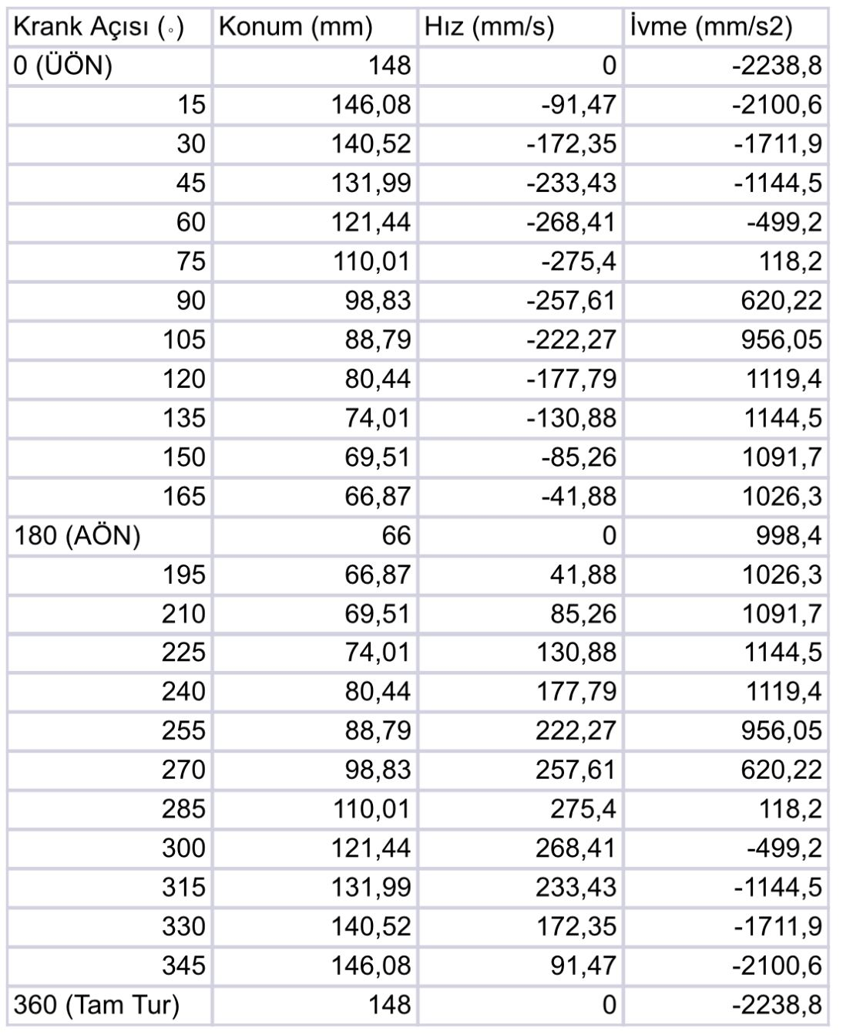

Fig.4
The analytical calculations of the mechanism were performed using MATLAB. In this study, the actual rotational speed of the slider–crank mechanism and the real dimensions of its components were taken as the basis to obtain position, velocity, and acceleration graphs, as well as corresponding numerical data tables.
2.2 Theoretical Calculations

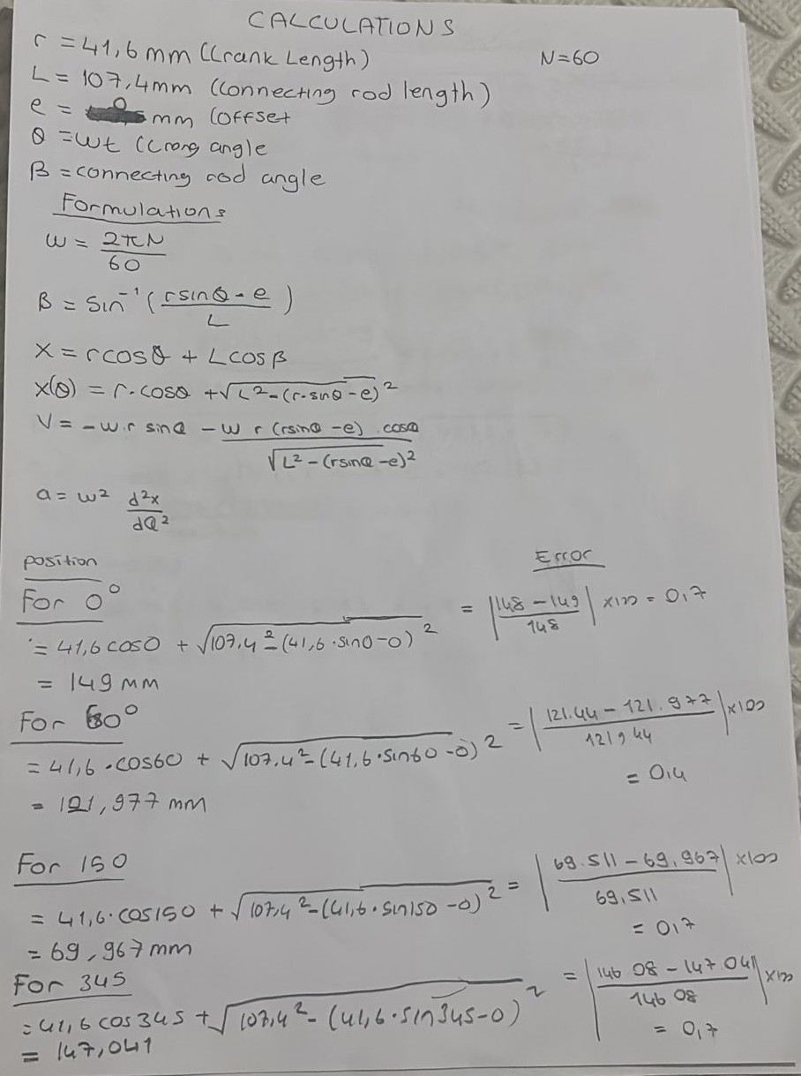
Fig.5

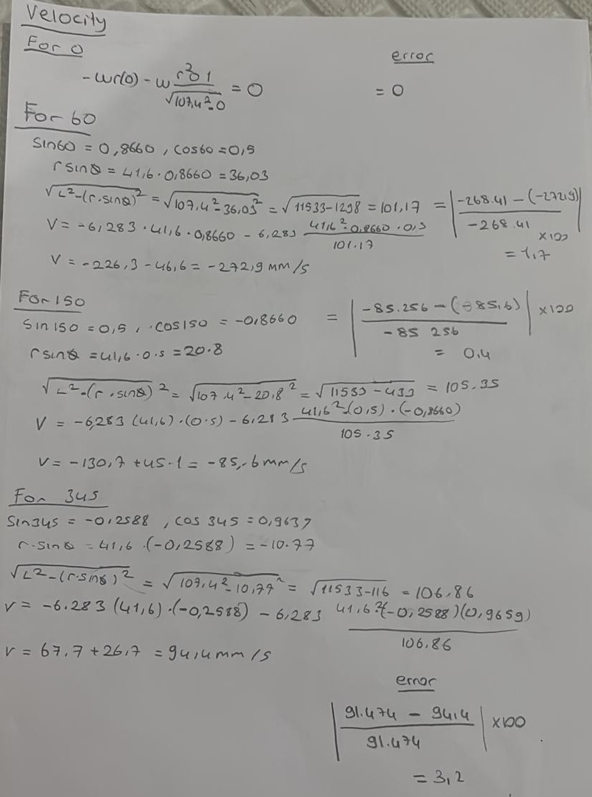
Fig.6

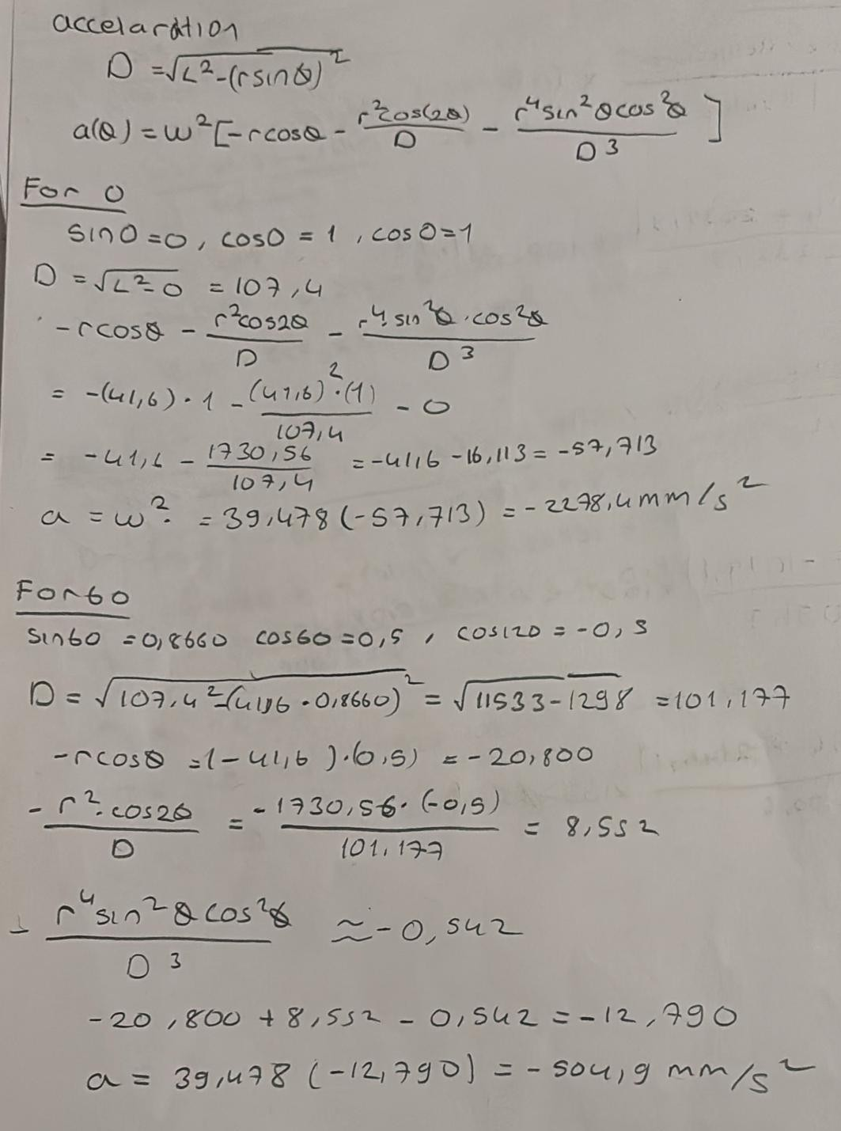
Fig.7

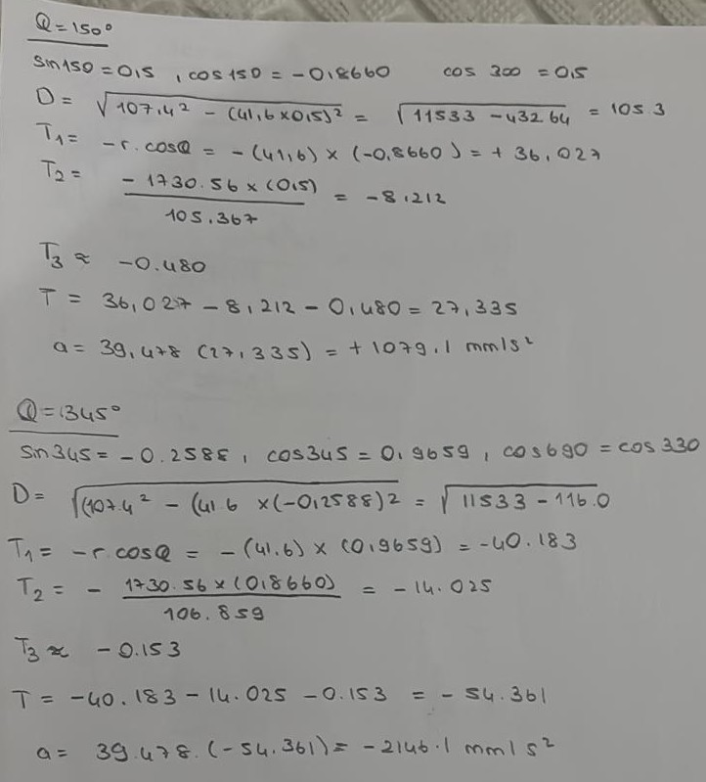
Fig.8

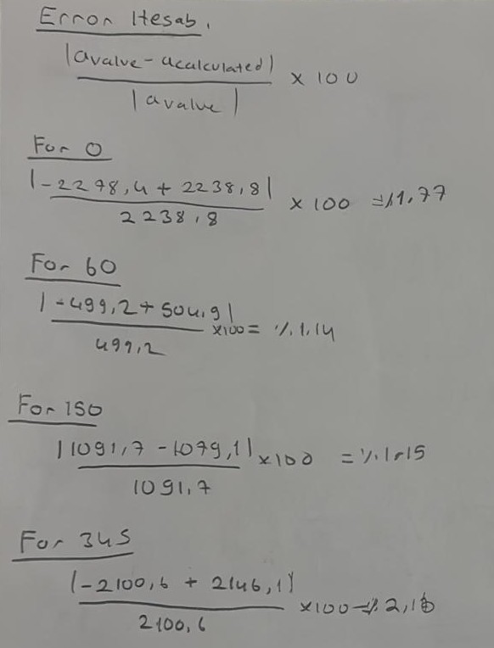
Fig.9

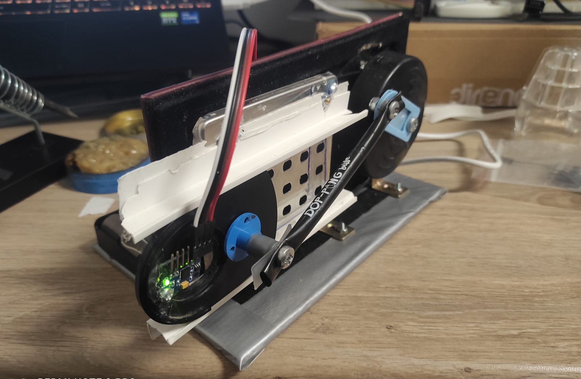
3. Photos of the Prototype
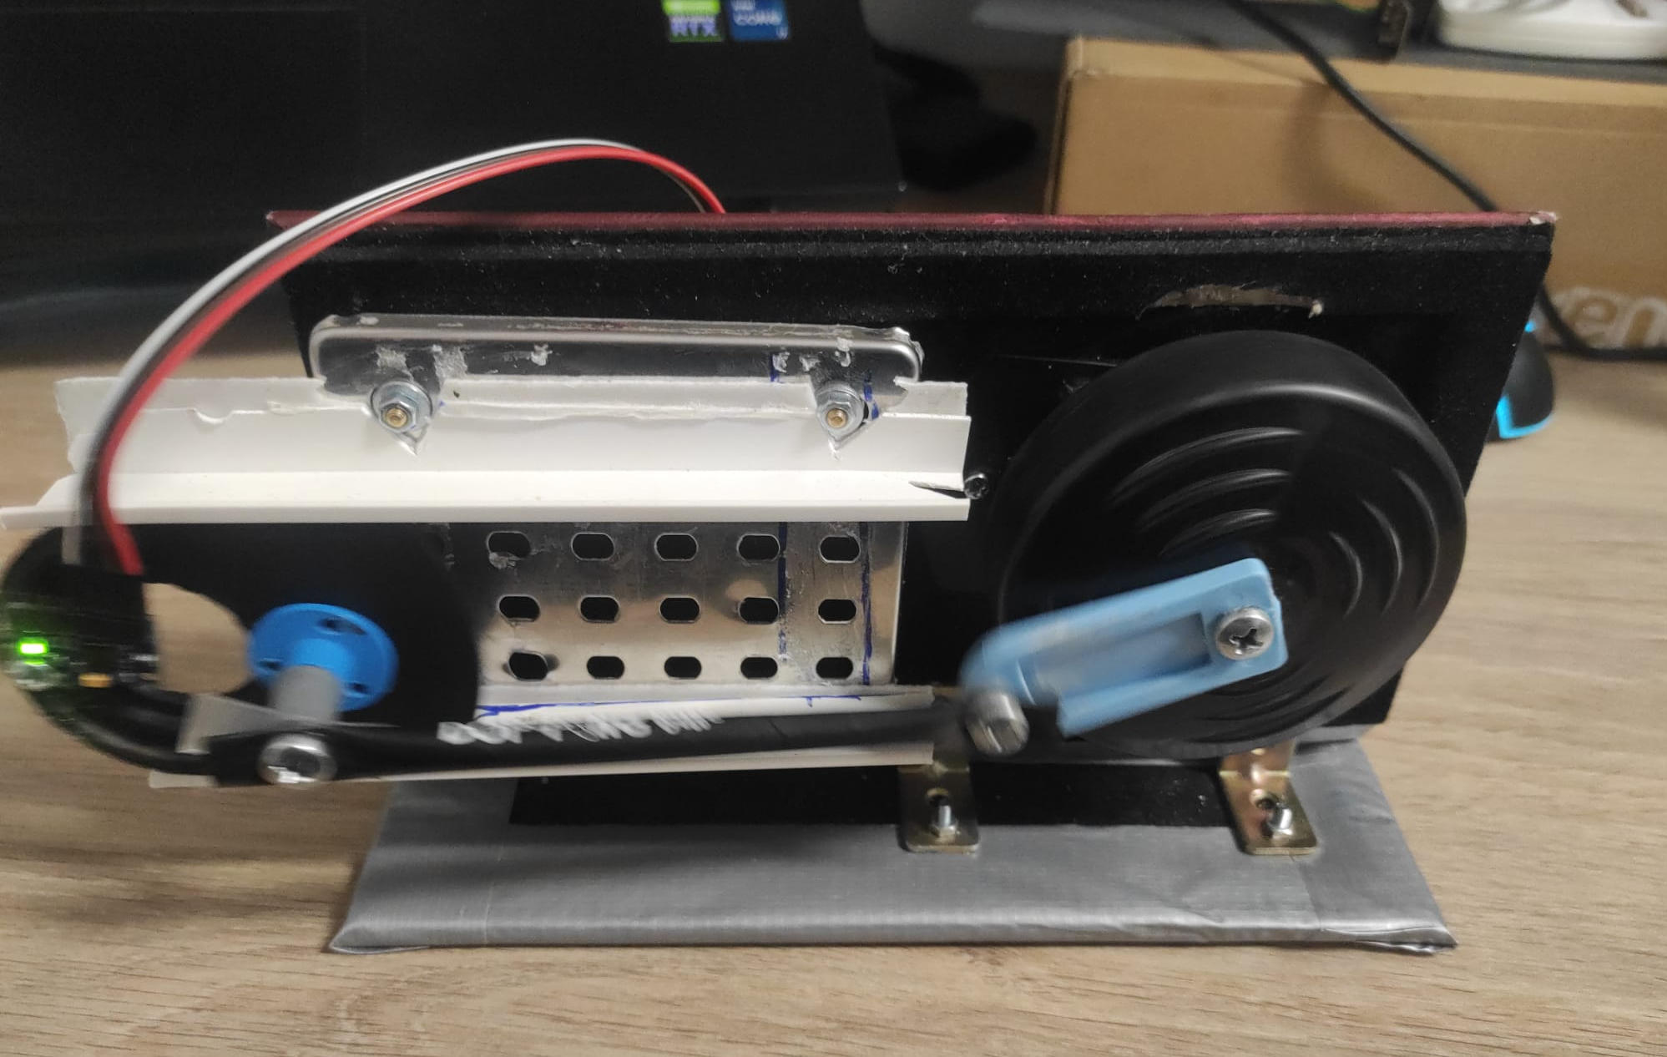
Fig.10
Fig.11
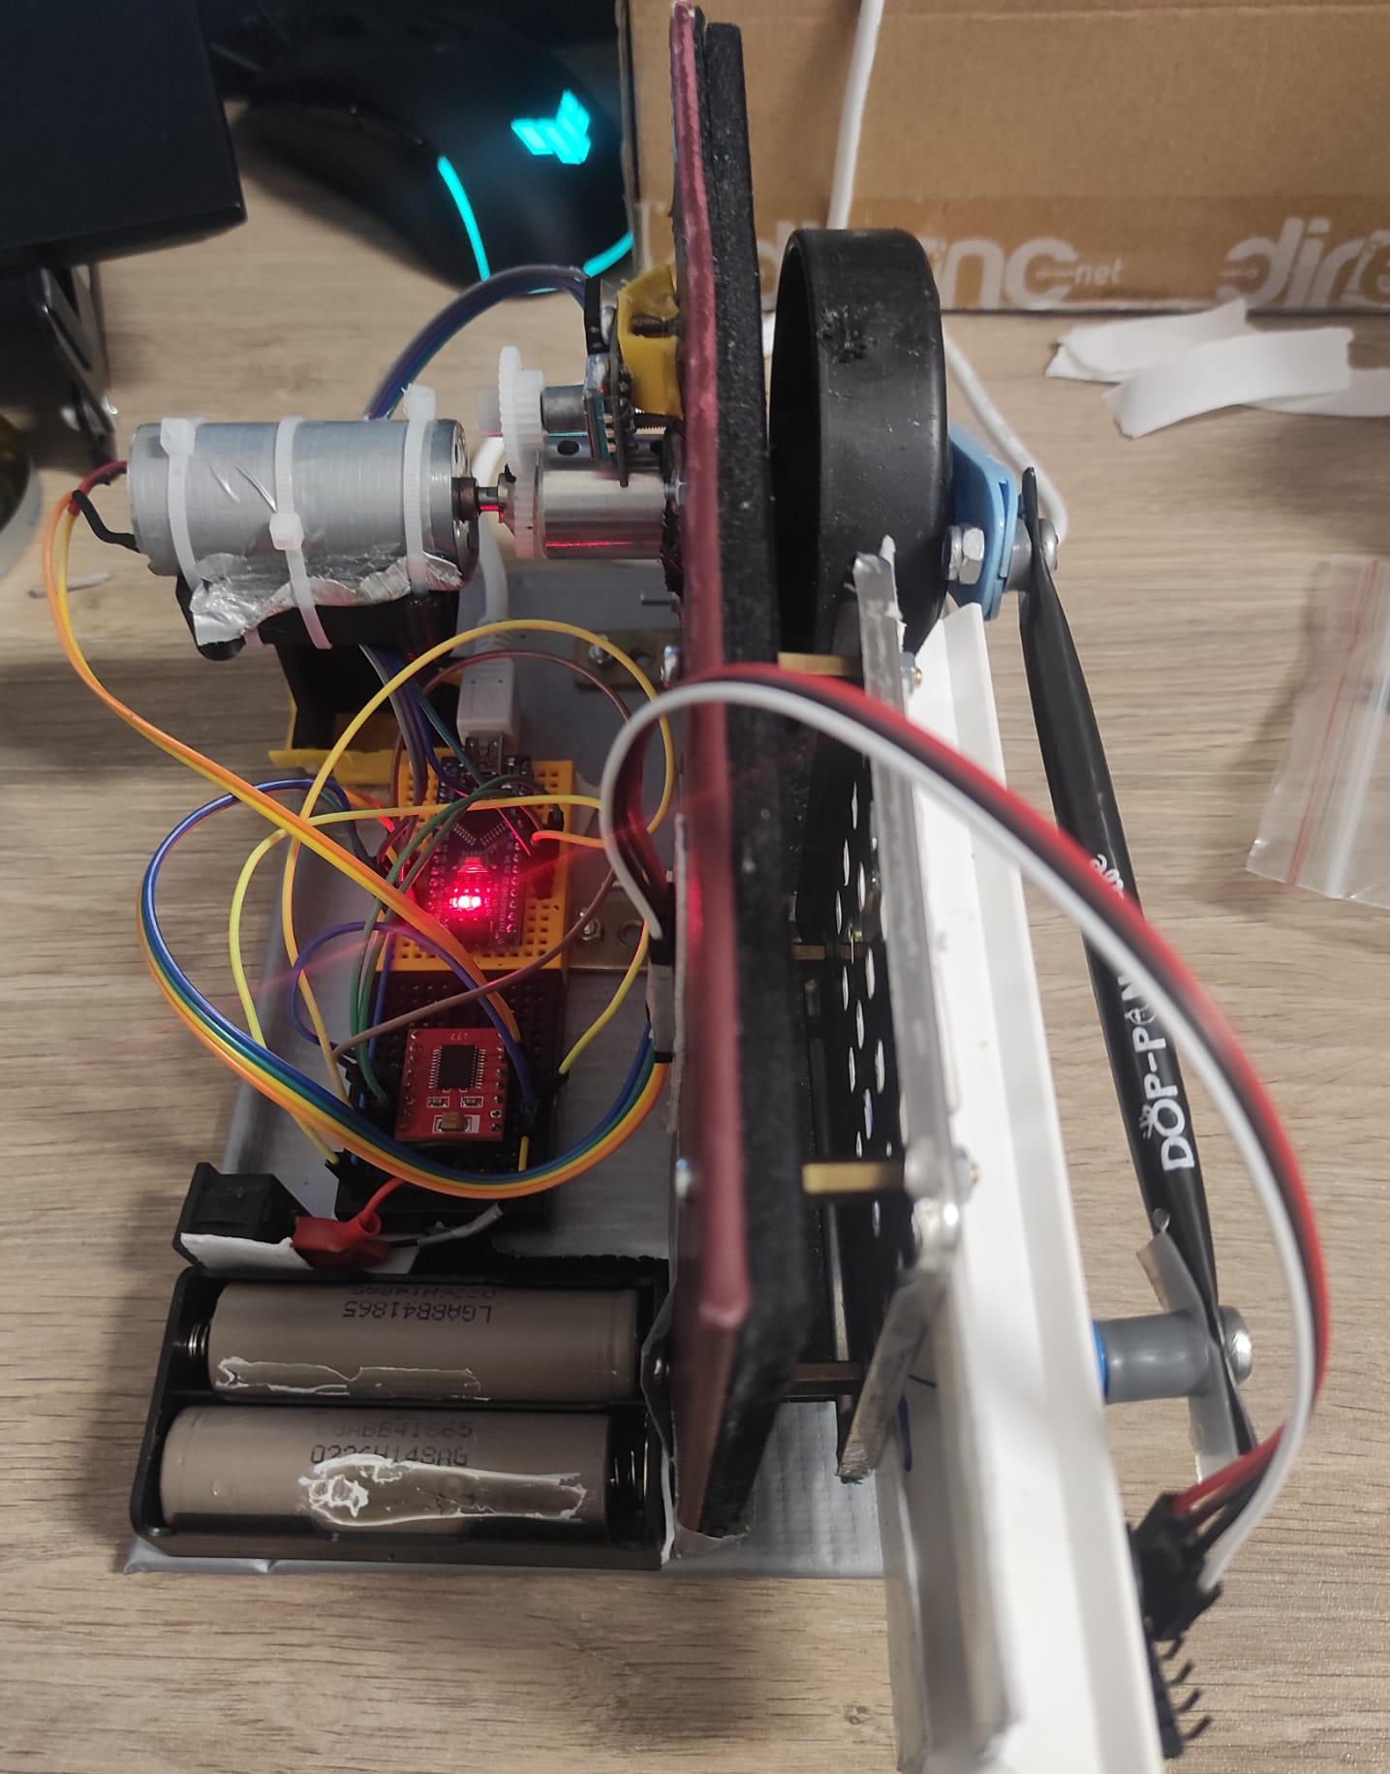

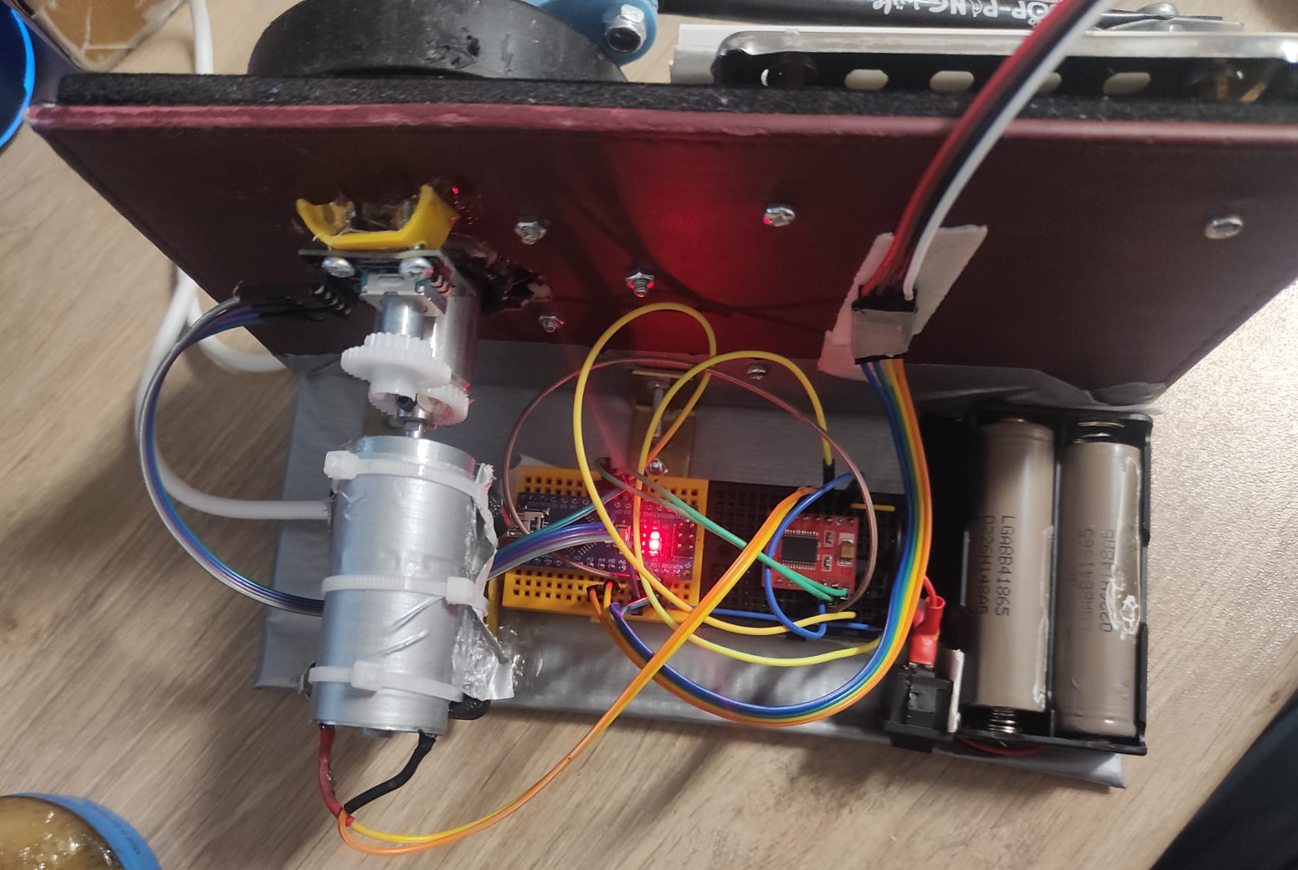
Fig.12

Fig.13
System Overview and Hardware Architecture
Within the scope of the project, a slider–crank mechanism that converts rotational motion into linear motion was designed and constructed. System control is achieved using an Arduino Nano microcontroller. The main components of the mechanism are as follows:

• Drive Unit: A DC motor with speed controlled via PWM and an associated motor driver circuit was used.
• Sensors: A rotary encoder was integrated to monitor the angular displacement of the crankshaft, and an MPU6050 sensor mounted on the slider block was used to collect acceleration data.
• Power Supply: Two 18650 Li-ion batteries were utilized to power the system.

4. Data Collection

4.1 Data Extraction Using Motion Tracking

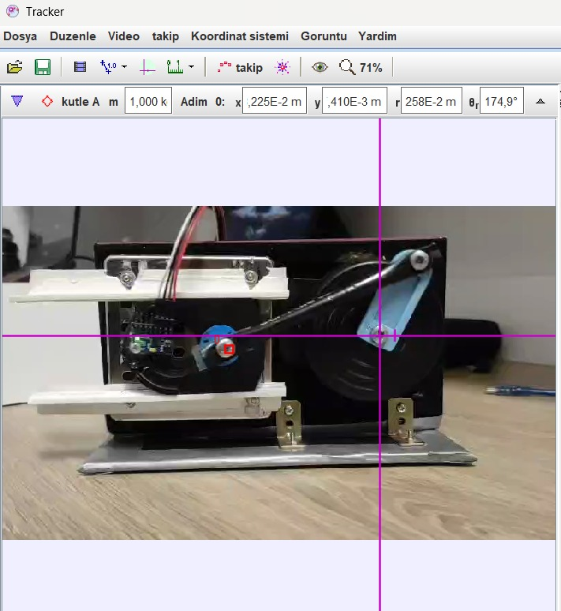
Fig.14
As shown in the figure, a coordinate system and a point mass were added at the connecting rod–slider connection. The red marker on the screw represents the defined point mass.
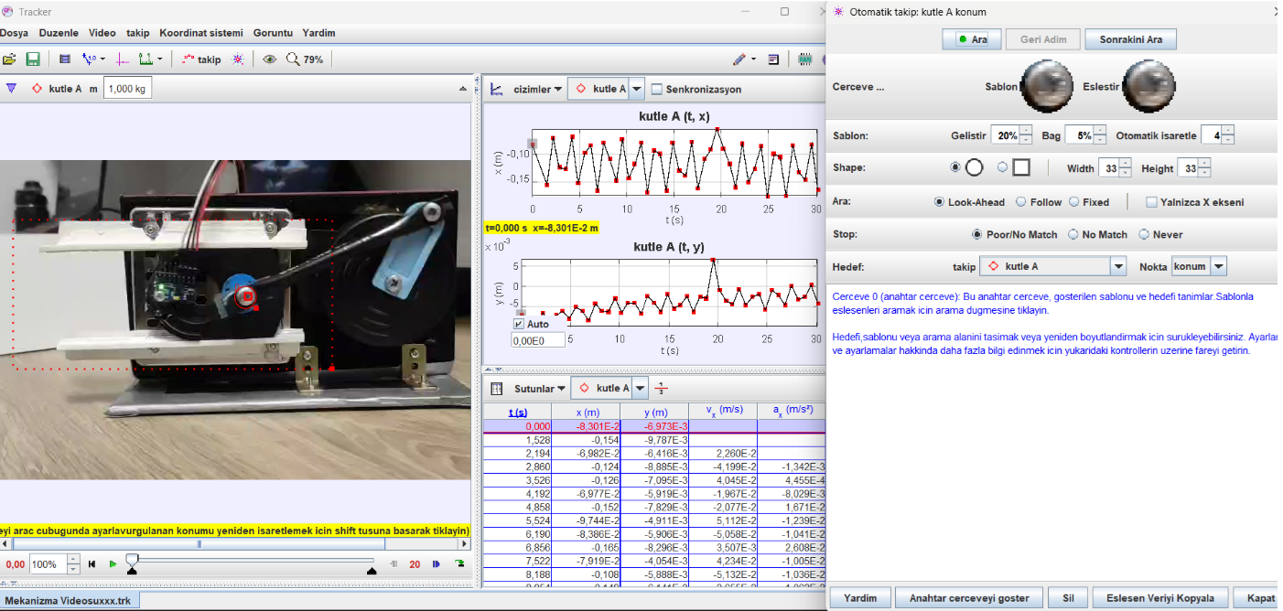
Fig.15
Subsequently, a search region was defined for the previously created point mass to enable tracking by the Autotracker. The Autotracker was then initiated using the search button located in the upper right corner.

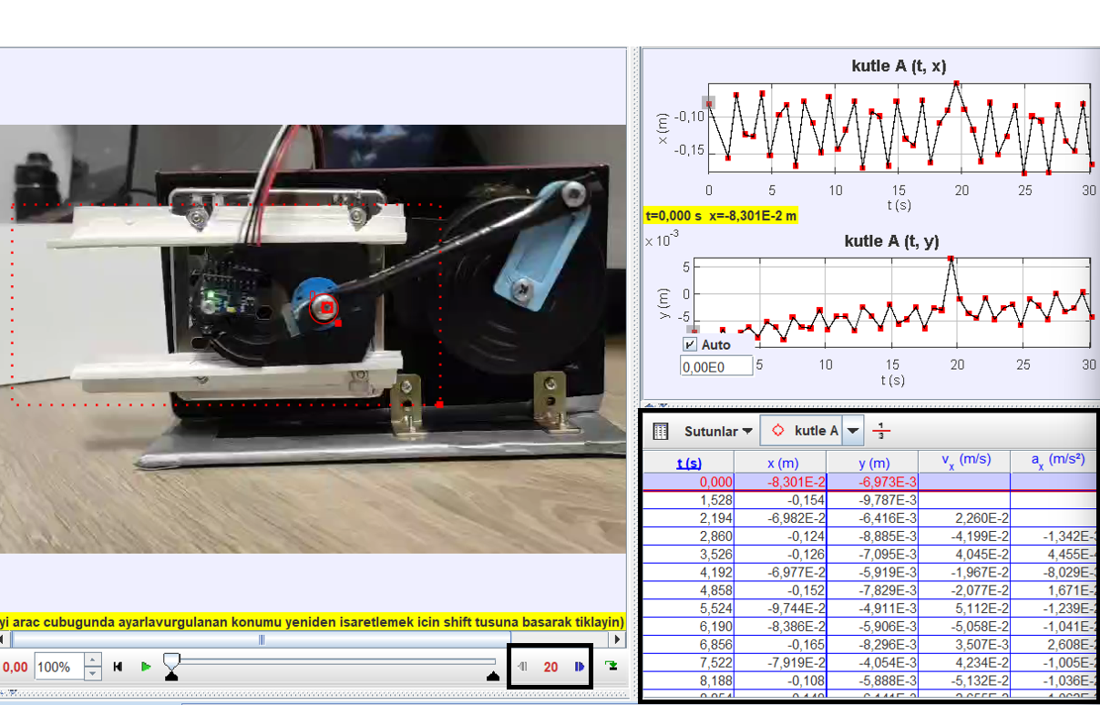
Fig.16
In the available video, the tracker captured more than 900 frames and initially generated data for every frame. To reduce the data olüme, the Autotracker was configured to record data at intervals of every 20 frames, as indicated in the small rectangle at the bottom left. The Autotracker was then restarted, and the previously displayed data in the large black area at the bottom right were cleared.

4.2 Data Extraction Using Sensor Fusion

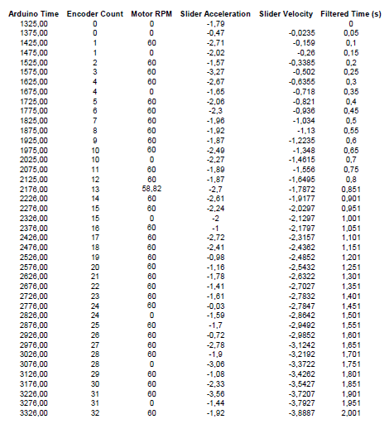
Fig.17
Data Collection Methodology
The data required for dynamic analysis were collected via the Arduino code at a sampling interval of 50 ms. The collected raw data (encoder count, motor RPM, and slider acceleration) were transmitted to the computer environment in real time using the PLX-DAQ software. Within the code structure, encoder signals were monitored using interrupt routines to obtain precise angular measurements.

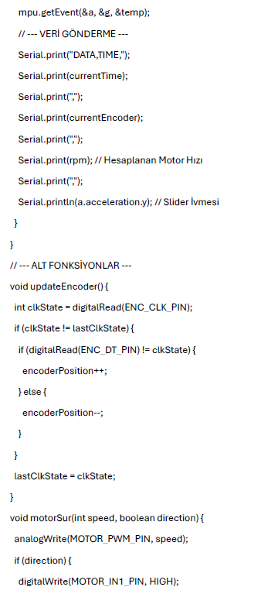
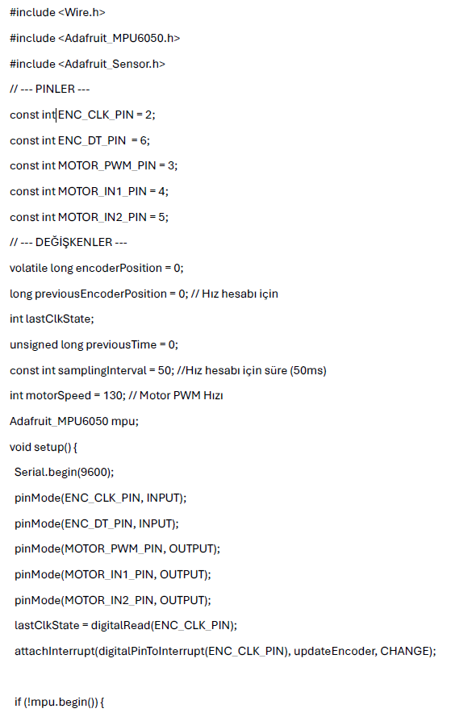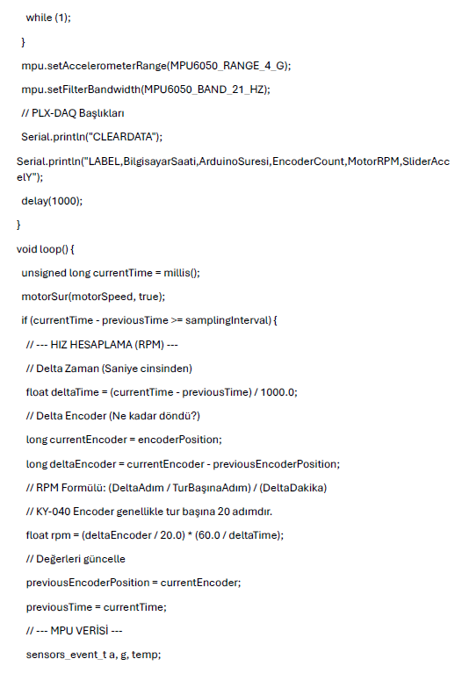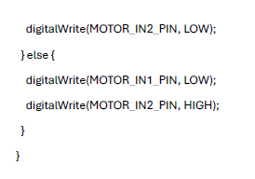
5. Cost Analysis and List of Materials
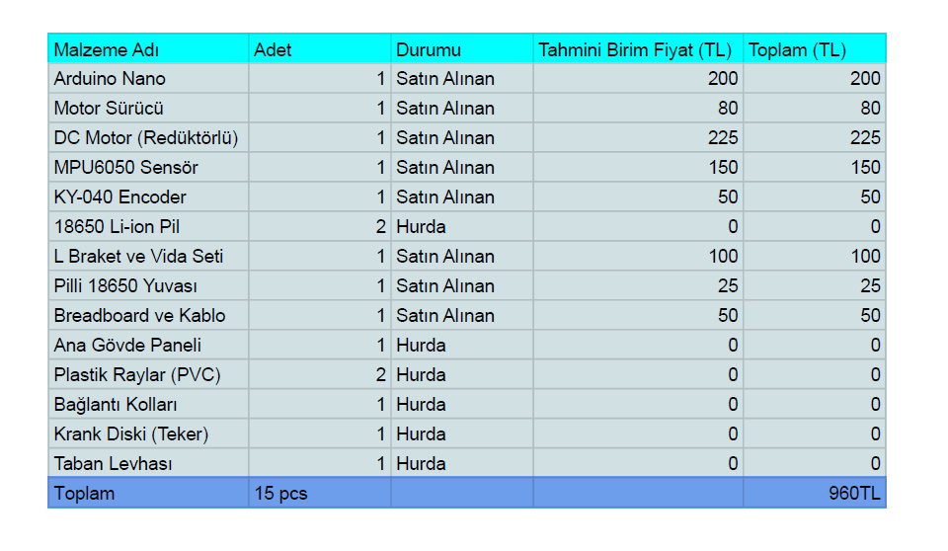
Fig.18

6. Simulation



https://drive.google.com/file/d/1_qM7AE7k8n9SXZLLMNjUbvUqvz1J2D-a/view?usp=sharing
https://drive.google.com/file/d/1QPx1LFRgeA6Zg-krbaNuKYTeBfWW5n8X/view?usp=sharing

7. Comparison of Results and % Error
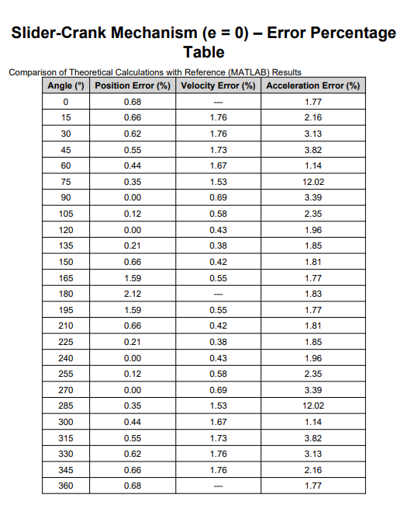

Fig.19

Error Analysis

When the theoretically calculated position, velocity, and acceleration values are compared with the reference results obtained from MATLAB, it is observed that the error percentages generally remain at low levels. The fact that the position errors are mostly within the range of 0–2% indicates that the geometric model used represents the actual behavior of the mechanism well. The increase in velocity and especially acceleration errors at certain crank angles can be attributed to numerical sensitivity arising from finite step size, numerical differentiation, and rounding errors, since acceleration is more sensitive to small variations in angular position. Moreover, neglecting effects such as friction, clearances (backlash), stiffness losses, and mass/inertia in the theoretical model also contributes to the discrepancies. Overall, the obtained error levels are within acceptable limits, demonstrating that the theoretical calculations adequately capture the kinematic behavior of the slider-crank mechanism.

Conclusion

In this project, a slider–crank mechanism was successfully designed, constructed, and analyzed.
The kinematic behavior of the mechanism was investigated through theoretical calculations and MATLAB-based numerical analysis.
Experimental data were obtained using video tracking and sensor-based measurements, and the results were compared with the theoretical predictions.

The comparison shows a generally good agreement between theoretical and experimental results.
The observed differences are mainly attributed to friction, joint clearances, and measurement uncertainties inherent in the experimental setup.
Despite these deviations, the overall trends of position, velocity, and acceleration are consistent with slider–crank kinematics.

This project provided practical experience in applying theoretical kinematic concepts to a real mechanical system and highlighted the importance of experimental validation in engineering analysis.

